**VOD Screen shots**

**1. Subscribe Topic *“sdk/test/request”***

**1-1. To get the video list, subscribe following message:**

*{*

*“message”: “list”,*

*“videofile”: “TEST”*

*}*

**1-2. To upload the video, subscribe following message:**

*{*

*“message”: “upload”,*

*“videofile”: “TEST”*

*}*

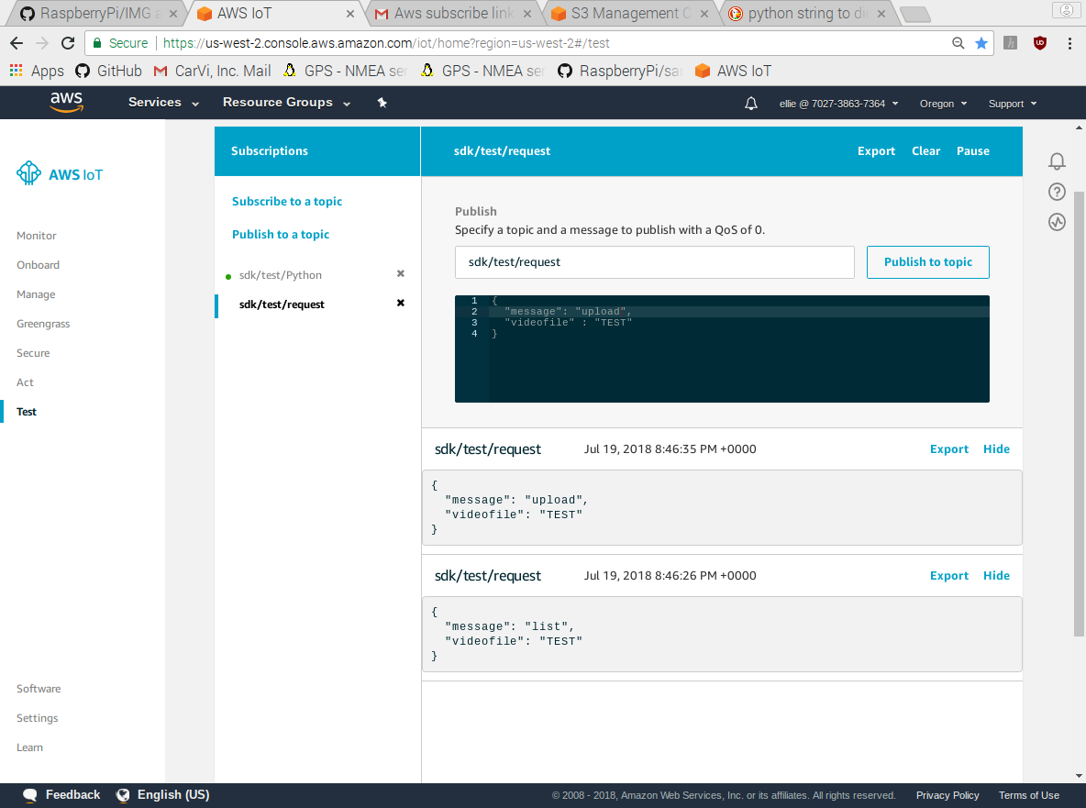

**2. Response on RaspberryPi terminal after subscribing the messages**

**2-1. Get the video list**

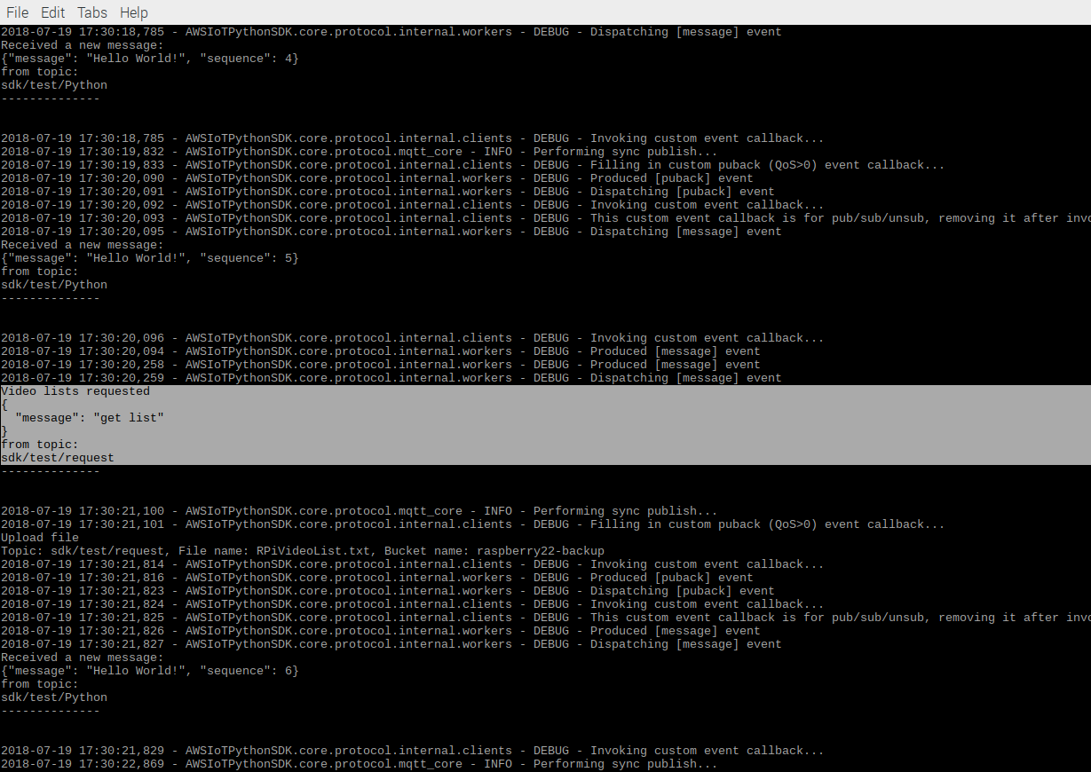

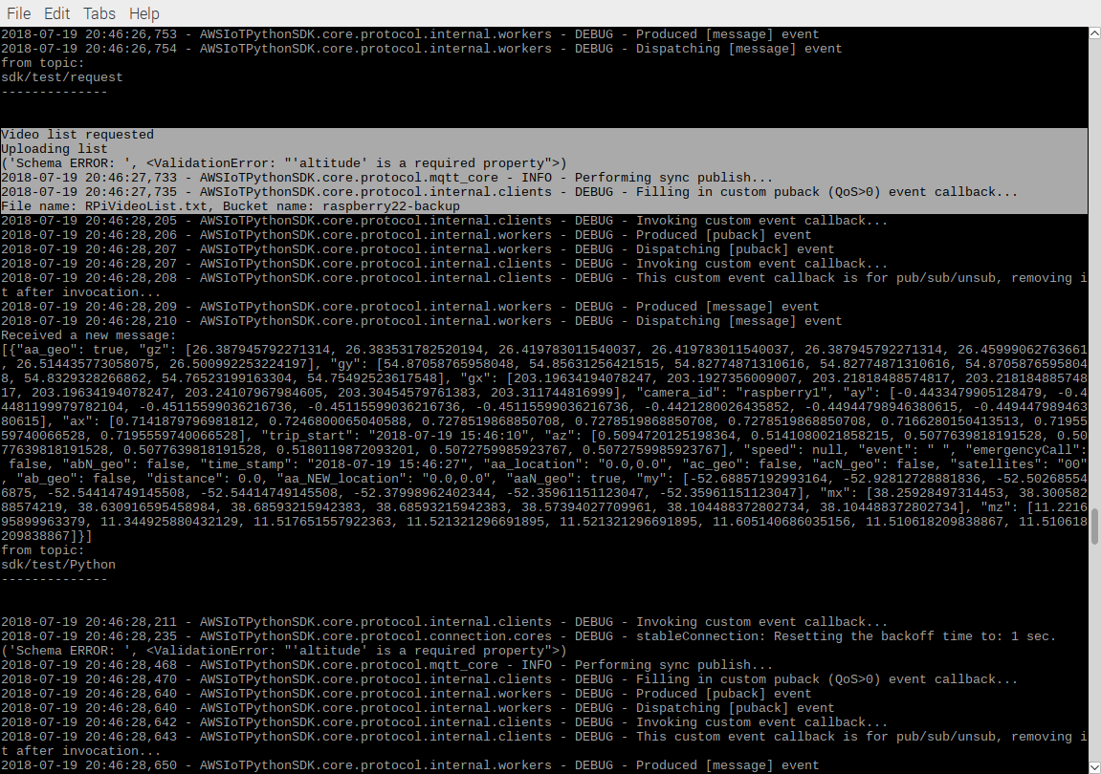

**2-2. Upload the video**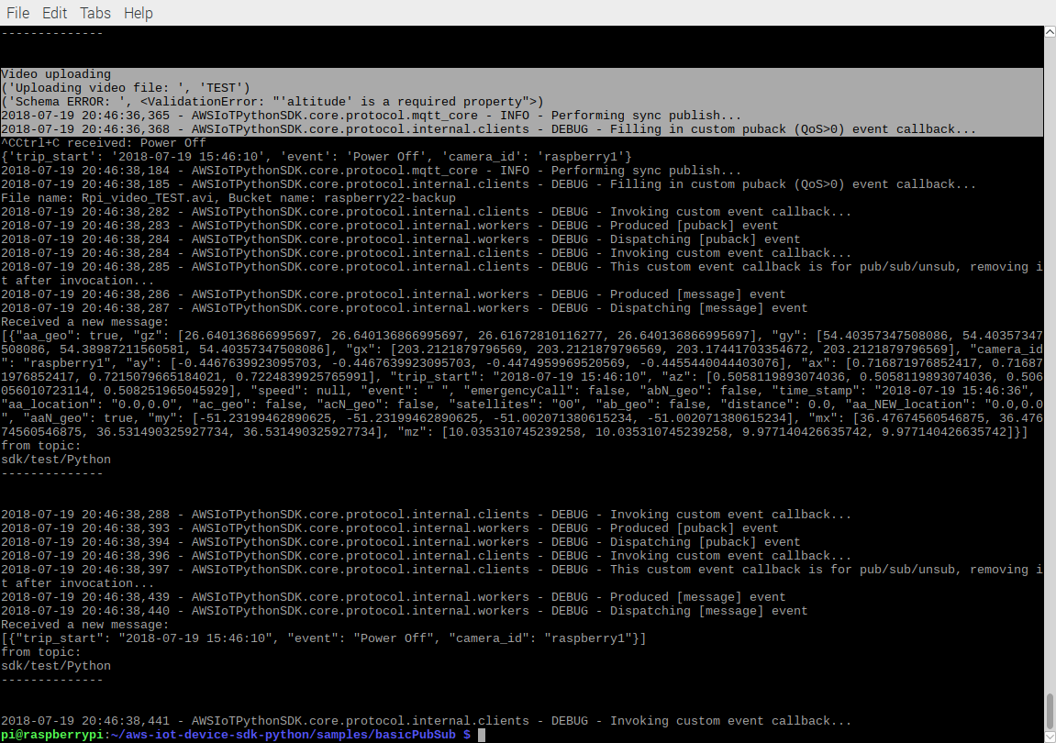

**Note: ignore the Schema ERROR on the screenshot. Testing the Json Schema at the same time**

**3. Screen shots of S3 bucket**

**Shows uploaded video list and the requested video file.**

